Md. Zohurul Haque  Professor  Department of Agricultural Botany  Faculty of Agriculture  - Mobile No : 01716594376  - Phone No : 01716594376  - Email : zhaquepstu@gmail.com   |  |  |  |  |  | 
Overview | Publications | Grants | Supervision | Fingerprint | Award
OVERVIEW
Biography
Dr Botella's research interests are in genetic engineering, molecular biology and signal transduction in plants.
Dr. Jimmy Botella is Professor of Plant Biotechnology at the University of Queensland. He obtained a degree in Quantum Chemistry from the University of Madrid (Spain) and a PhD in Biochemistry from the University of Malaga (Spain). After postdoctoral positions at Michigan State University and Pennsylvania State University he joined the University of Queensland in 1995. At UQ he founded the Plant Genetic Engineering Laboratory (PGEL) specialising in the fields of tropical and subtropical agricultural biotechnology for almost 15 years. J. Botella has eleven international patents in the field of Plant Biotechnology and is a founding member of two biotechnology companies (Coridon Ltd. and Origo Biotech).
Dr Botella is a member of the Plant Molecular Biology and Biotechnology research group.
Some highlights of the Plant Genetic Engineering Laboratory’s research:
Research Interest
Dr. Botella’s research has two major foci: basic cell biology and applied biotechnology. In cell biology he is interested in studying the function of the Heterotrimeric G proteins in plants. This family of proteins is extremely important in humans but their role in pant systems is still largely unknown. Dr. Botella’s research has strongly contributed to the current body of knowledge available in plants with critical contributions such as the discovery and characterization of the first plant gamma subunits and the establishment of these subunits as the critical element conferring function specificity to all plant G proteins. Dr. Botella’s team has also discovered the important role that these proteins play in defense against pathogens. New and unpublished data has now revealed that G proteins are important yield enhancing factors in crops such as rice. Another research interest resides in the communication between plants and insects. There is plenty of knowledge of how important smell, volatiles emitted by the plant, is for foraging insects in order to determine their host preferences. Nevertheless, most of the available studies have been performed using synthetic chemicals in artificial experimental settings. Dr. Botella’s team and collaborators have genetically engineered plants to produce different volatile mixes in the flowers in order to perform in vivo behavioral studies in insects.
Biotechnology research at the Plant Genetic Engineering Laboratory mostly arises from discoveries made in basic research. The PGEL focuses in tropical and subtropical crops. These crops have attracted little attention in terms of biotechnology but are essential sources of food and energy for a large part of the world’s population, especially in Asia and the Indian subcontinent. The PGEL has developed a number of platform technologies that can be applied to multiple crops in order to confer resistance to pathogens, modify plant architecture and control flowering time.
Current research projects include:
- Plant heterotrimeric G proteins: New roles in defence, stomatal control and ABA perception.
- Putting smells into context: using in vivo technologies to understand plant-insect odour communication.
- Use of host-derived RNA interference technology to control plant pathogens (especially pathogenic fungi and nematodes).
- Control of Fusarium wilt disease.
- Genetic improvement of grain crops.
- Genetic engineering research projects

Qualifications
- PhD, Universidad de Malaga
- MSc in Quantum Chemistry, Universidad Autonoma de Madrid
- BSc in Quantum Chemistry, Universidad Autonoma de Madrid

Previous positions
2009-2014 ARC QEII Research Fellow, University of Queensland
2007-2009 Research Fellow, University of Queensland
2002-2007 Senior Research Scientist, DPI Victoria
2001-2002 Postdoctoral Researcher, University of Bristol, UK
1996-2000 PhD Scholar, University of Bristol, UK

Teaching overview
BIOL1130 -Frontiers in Biology (Co-coordinator)
ANIM3362 - Evolutionary Processes
GENE4001 - Advanced Studies in Genetics and Genomics
BIOL5542 - Conservation Genetics
AGRI5502 - Advanced Breeding and Biotechnology in Action

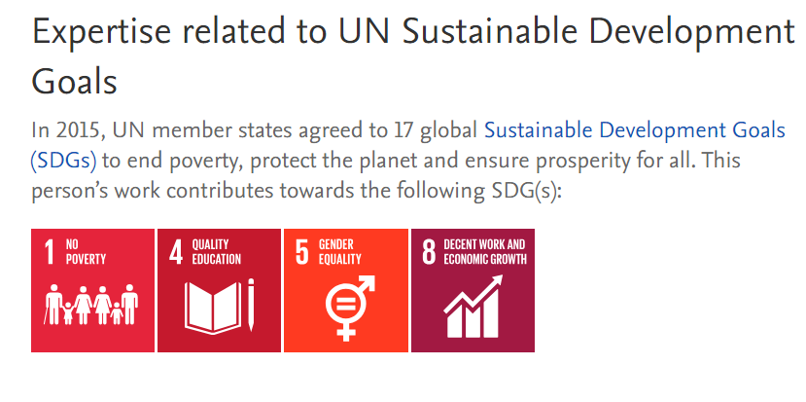
PUBLICATIONS
Journal(30):
Book/Book Chapter(3)
Conference Paper(20)
Patent(1)
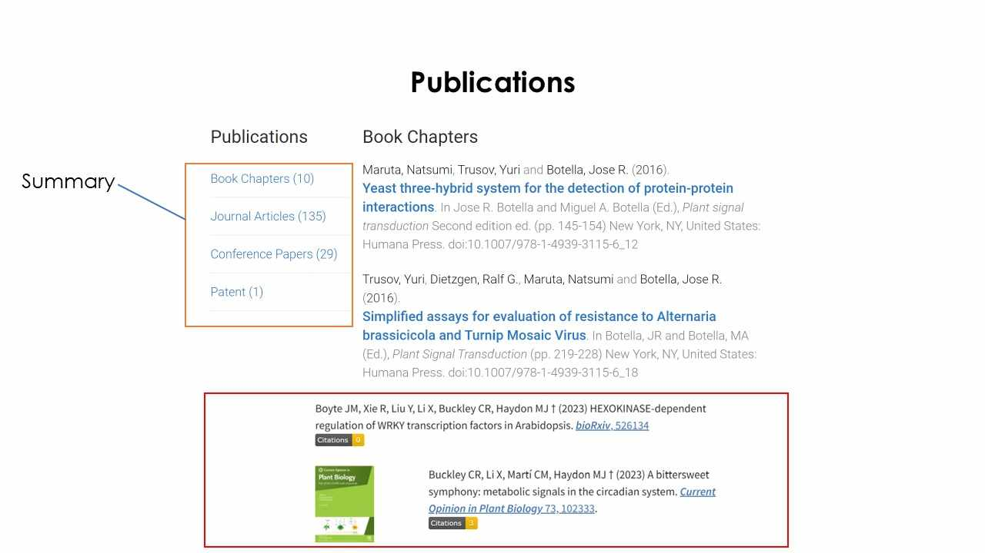

GRANTS
- Delivery of a pest and disease diagnostic step change for sugarcane industry
(2023–2026) Sugar Research Australia Limited
- Services to test mill juice samples for RSD using the LAMP method
(2022–2023) Sugar Research Australia Limited
- Point of management assays for early detection of pig enteric and respiratory disease
(2021–2025) Australian Pork
- Pre-commercial development, testing and validation of RSD LAMP assay for sugar mill roll-out.
(2021–2022) Sugar Research Australia Limited
- Maximising pineapple production for Australian farmers using genome editing
(2020–2024) ARC Linkage Projects

SUPERVISION

MS, PhD and MPhil

Current Supervision
- Development of Transgene-free Genome Editing Technologies for the Improvement of Dicot Crops
Doctor Philosophy — Principal Advisor
Other advisors:
  - Dr Peter Crisp

Completed Supervision
- Functional Characterization of Heterotrimeric G Protein Alpha and Beta Subunits in Tomato
(2021) Doctor Philosophy — Principal Advisor
Other advisors:
  - Dr Yuri Trusov

FINGERPRINT/ RESEARCH EXPERTISE KEYWORDS
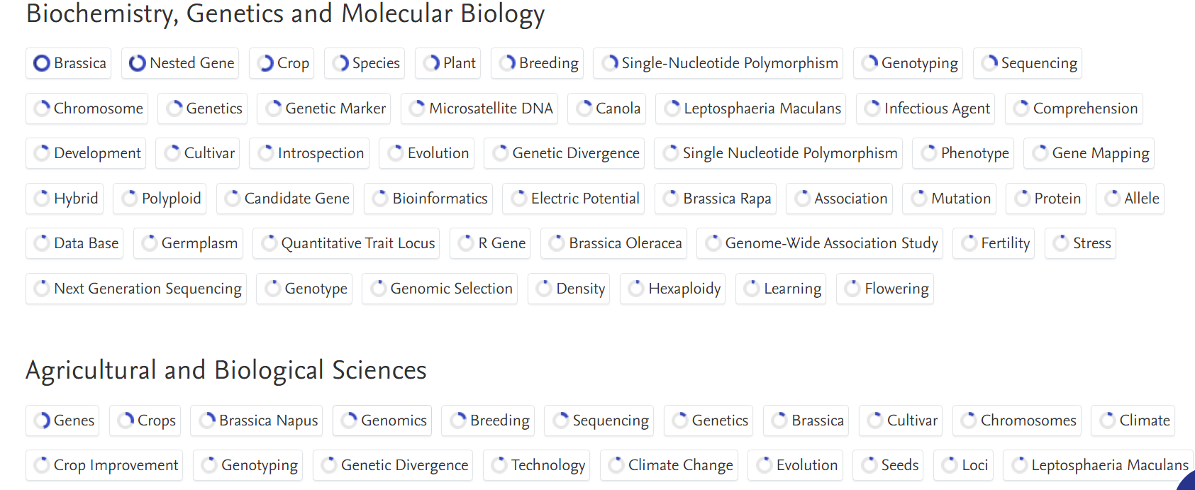
AWARD
- 2024

John Glover Research Support Grant
Eves, Alex (Recipient), 2024
Prize
- 2023

Finalist, Asian-Australian Leadership Award
Wang, Kimberley (Recipient), 15 Nov 2023
Prize: Award

Fellow of the Higher Education Academy (FHEA)
Chung, Ricky (Recipient), 1 Nov 2023
Prize: Fellowship

